Lab assignment- 2.5
NAME: U . Harika
HALL-TICKET: 2303A51262
Task -1: Refactoring Odd/Even Logic (List Version)
Prompt : Write a Python program to calculate the sum of odd and even numbers in a list Code and output :
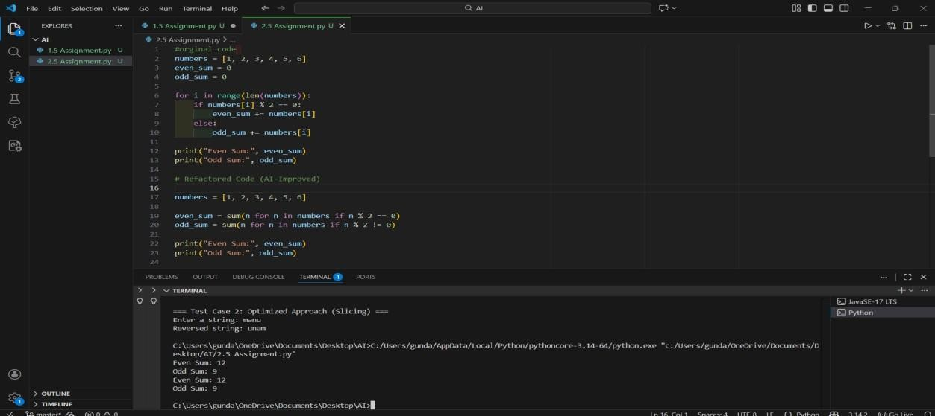
Explanation
The refactored code is shorter, more readable, and efficient.
It removes manual loops and uses Python’s built-in sum() with conditions, making the code easier to maintain.
Task 2: Area Calculation Explanation
Prompt : Explain a Python function that calculates the area of different shapes Code and output :
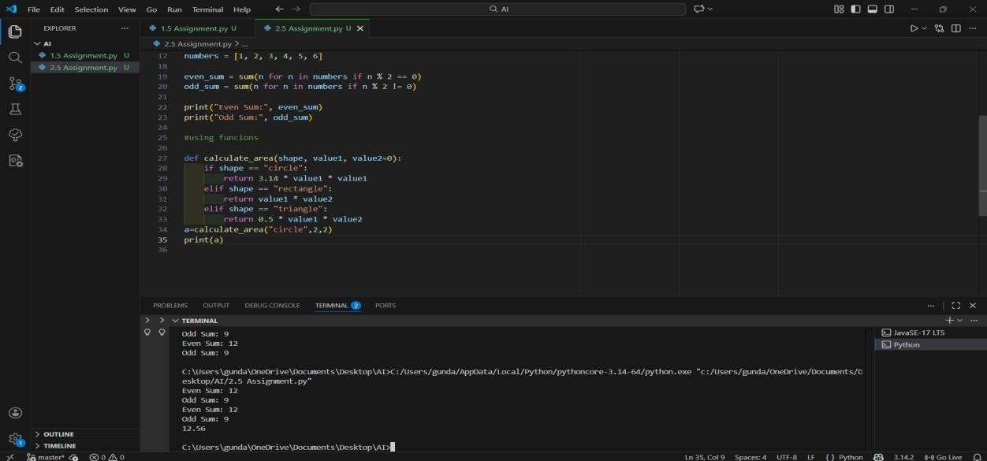
Explanation Gemini clearly explains how the function works for different shapes.
It describes the parameters, logic flow, and formulas used, which helps beginners understand the code easily.
Task 3: Prompt Sensitivity Experiment
Prompt 1: Write a Python program to calculate the sum of even and odd numbers in a list
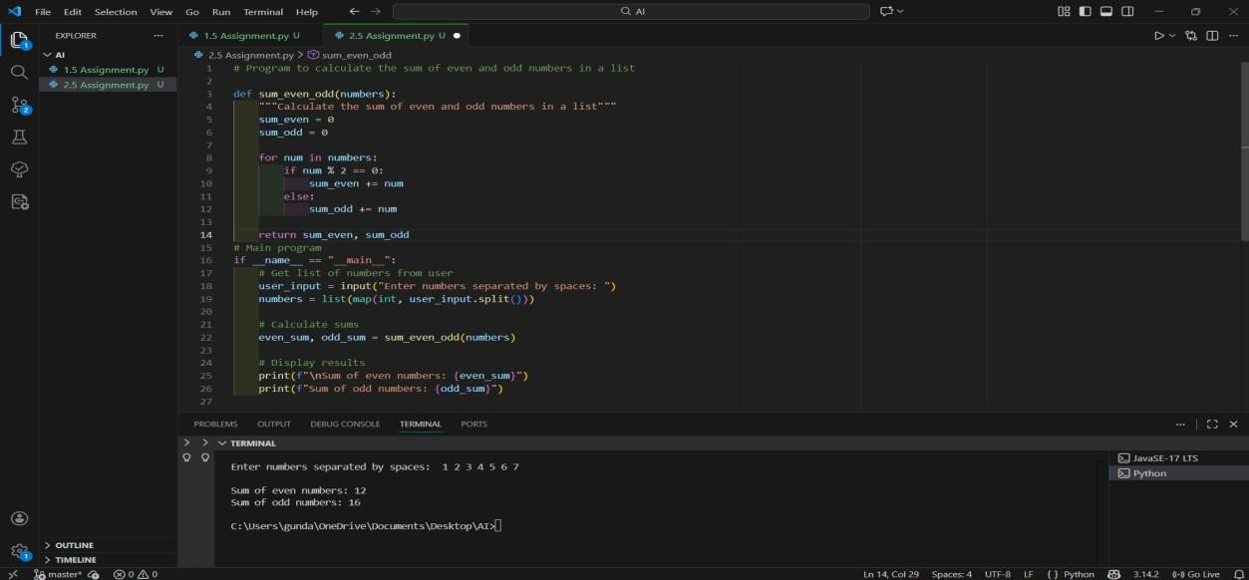
Explanation:
For Prompt 1 (Basic Prompt), Cursor AI generated a simple loop-based program using conditional statements. This version is easy to understand and suitable for beginners, but it uses more lines of code and manual variable updates.
Prompt 2: Write a clean and readable Python program to find the sum of even and odd numbers in a list suitable for beginners Code and output:
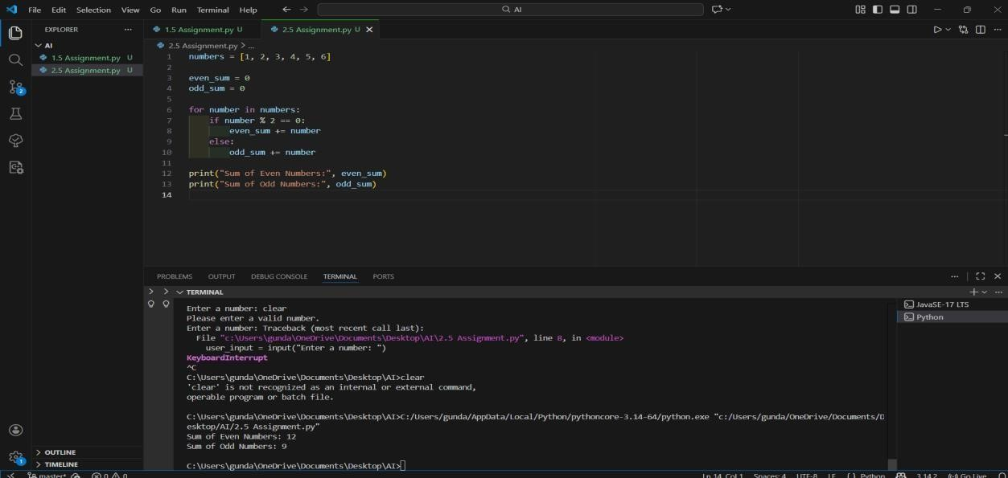
Explanation : For Prompt 2 (Readability-Focused Prompt), the AI produced code with clearer variable names and better formatting. Although the logic is similar to the basic version, readability and clarity were improved, making the code easier to review and maintain.
Prompt 3: Write an optimized Python program to calculate the sum of even and odd numbers in a list using
built-in functions Code and output:
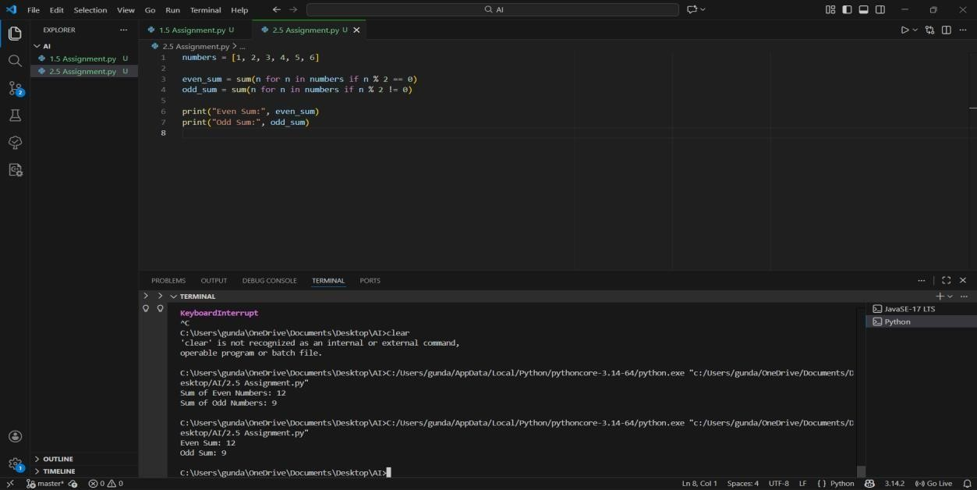
Explanation: For Prompt 3 (Optimized Prompt), Cursor AI generated a more efficient solution using Python’s built-in sum() function along with conditions. This version reduced the number of lines and improved code efficiency while maintaining correctness.
Prompt 4 : Write a Python program to calculate the sum of even and odd numbers in a list using functions Code and output :
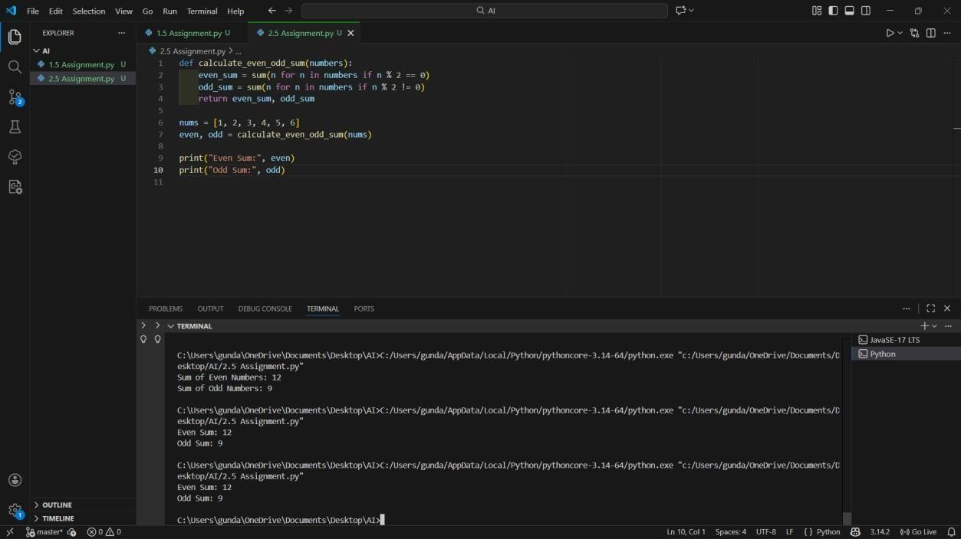
Explanantion:
For Prompt 4 (Function-Based Prompt), the AI created a modular solution using a user-defined function. This approach improves reusability, debugging ease, and maintainability, making it suitable for larger applications.
Task 4: Tool Comparison Reflection

Reflection
Based on the experiments performed in this lab, Google Gemini, GitHub Copilot, and Cursor AI each have different strengths.
Google Gemini is very useful for understanding code, as it provides clear explanations and works well in Google Colab, especially for beginners.
GitHub Copilot offers real-time code suggestions inside VS Code and is best suited for daily development and writing production-ready code.
Cursor AI is effective for experimenting with different prompts, refactoring code, and analyzing multiple coding approaches.

